Project Usage Manual

BeNutritious

Eat healthy Stay Healthy.

Submitted For:
SER515 – Software Enterprise: Inception and Elaboration.
Arizona State University

Submitted By:
Akash Chugh
ASU ID: 1211165446
Email: Akash.Chugh@asu.edu

Software installation
Open Android Studio 2.2 and import the folder under BeNutritiousAkashChugh-->src-->BeNutritious2.
The folder BeNutritious2 is the working directory and contains all the files and related folders.
Alternate Option :
Open the folder BeNutritiousAkashChugh-->apk and under this directory install the app-debug.apk and install the application

Build
The application is built using Android Studio 2.2. The build file is built using Gradle.

Usage

- Open the Application BeNutritious and enter your name, Age and Gender and select your lifestyle. Click on next

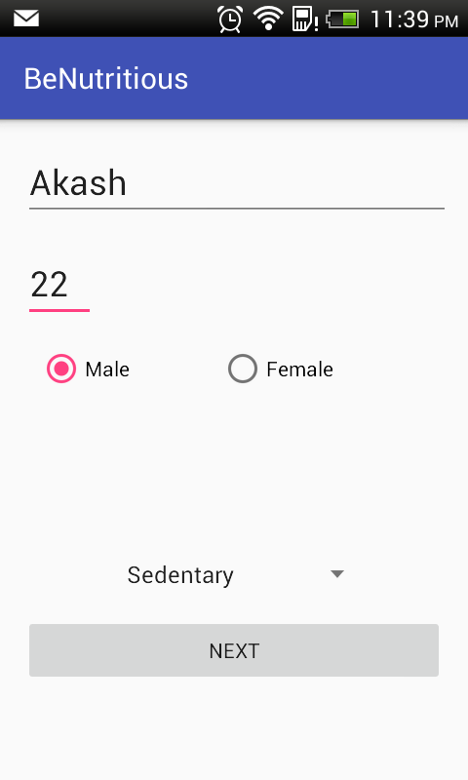

- Click on Daily Calorie Need
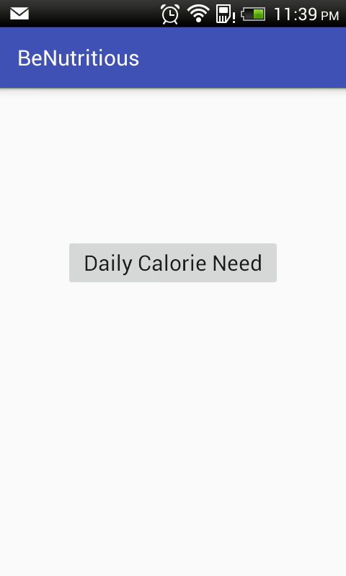

- The screen display the calories needed. After five seconds, a button(Dive Deeper) appears. Click on that button.

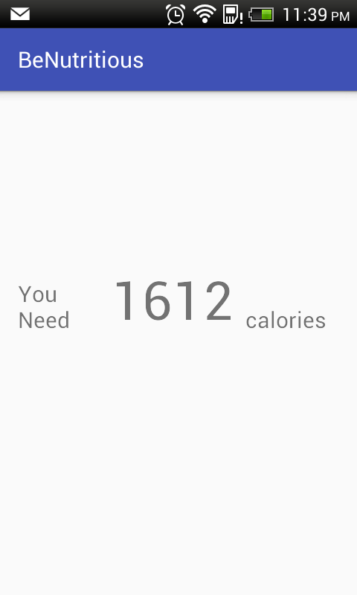

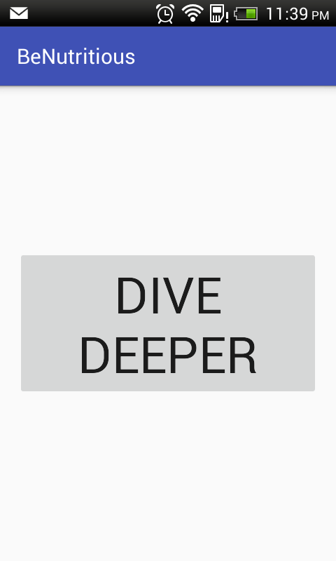

- The screen shows the nutrients required for your body for the day.
- Click on make more sense.
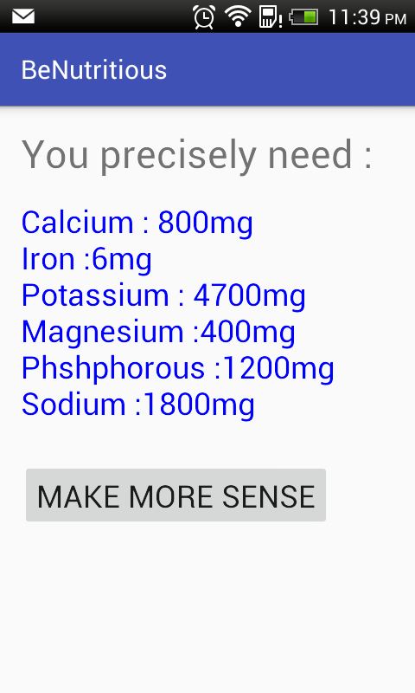

- Select a food Category that you consumed from the day,such as Fast Foods,Bread and Cereals or any Food category supported. This selection should be done in the first selection box.
- Select the sub category of sub food
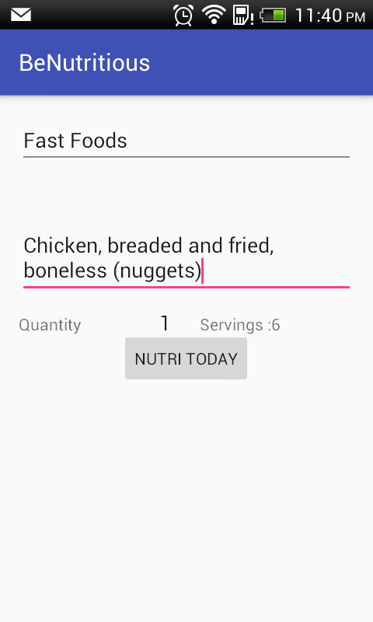

- The screen displays the required nutrients(after having the meal).
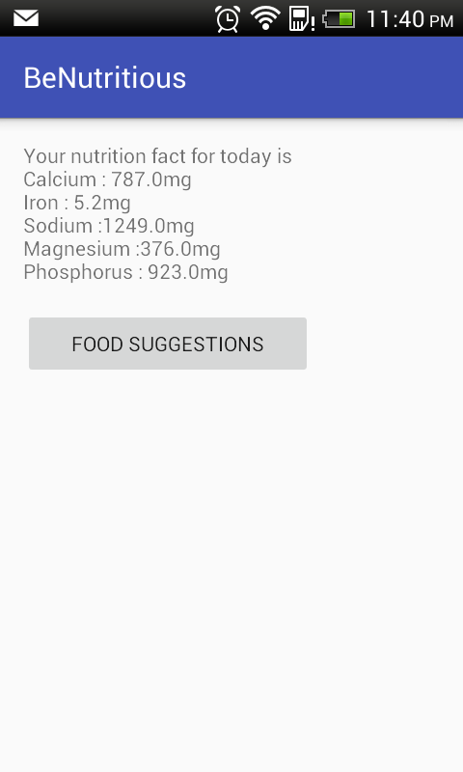

- Click on food suggestions to get a suggestions of food options.
